33.34: It takes the light an additional 4.2 ns to travel 0.840 m after the glass slab is inserted into the beam. Thus,
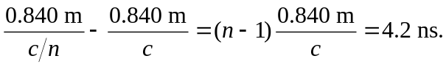
We can now solve for the index of refraction: 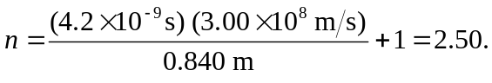
The wavelength inside of the glass is
